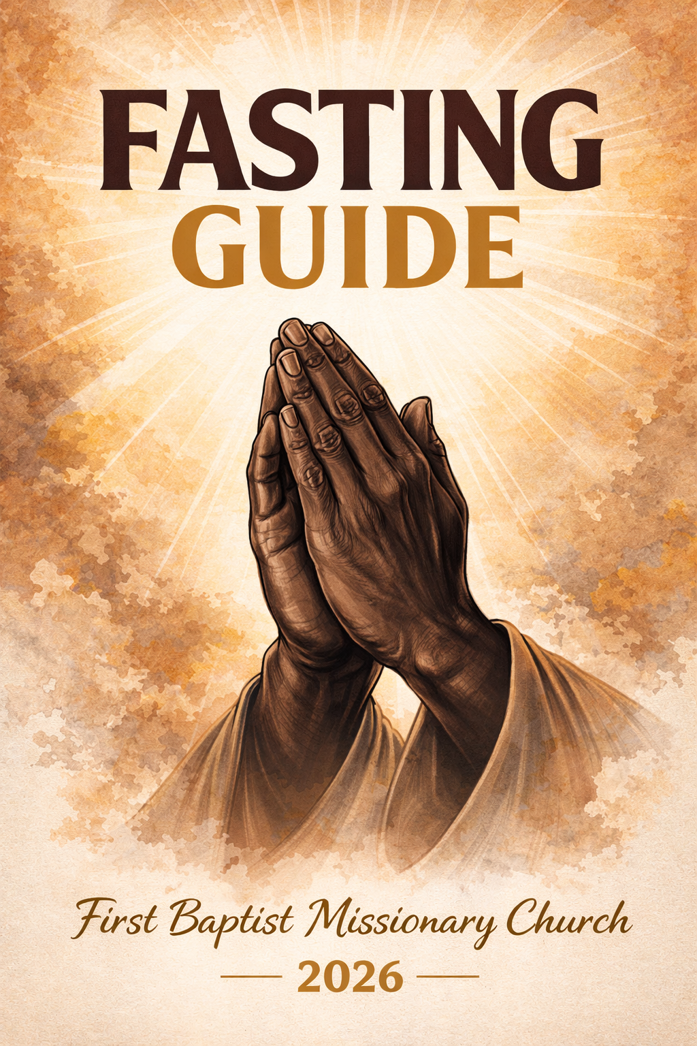


Greetings to you,

Welcome to our Fasting Devotional Guide. Praise God for the theme:” Walking In the Authority of God”. But what does this mean? How can we exercise God's authority in our daily lives?

- We must first understand our IDENTITY in Christ

- We must understand that God is all powerful

- As believers, we must know we too have the same power that Jesus possessed, given to us by the Father, through His Son and the Holy Spirit.

To walk in the authority of God, we must remember that we are children of God and He is our Father. God loves us so much and desires that we enjoy life while embracing His love in our lives and the purpose He has for our lives. It is time that we trust in God’s power and use that same power as we share God’s love and words to others. We must remain focus on the things God has called us to do and not become distracted from our tasks. We belong to the Lord and empowered with His Spirit, we are called to greater things in our lives.

With that, I pray you join us in a 6-Day period of Fasting and Prayer during the Holy Week. As we prepare ourselves to observe Jesus’ last week on earth before going to the cross to die for our sins, let us take this time to fast and pray to draw closer to God. Let us use this time to hear clearly from the Lord as He reveal to us the truth of who we are, the very purpose of our existence, and be endowed with His presence as we walk in His authority. The divine purpose of fasting is to work on our flesh so that God’s Spirit can move in our lives, transforming us into what He already knows we are. While fasting, our main source of “food" is God’s presence and His Word, so it is very important that you spend time with God daily; removing as many distractions as possible so we can hear clearly from Him.

Remember that fasting is not just about abstaining from food but about becoming intimate with God and serving others. May this special time with Him bring you clarity, peace, and divine blessings.

In Jesus’ name,

George P, Windley, Jr.

Rev. George P. Windley, Jr. Pastor



PLEASE NOTE:

Pastor George Windley, Jr and the First Baptist Missionary Baptist Church advise all members and participants of the Holy Week Fast to consider their personal health needs and to consult their personal health physician prior to beginning this fast. Therefore, we specifically disclaim any responsibility from any physical reaction from this fast.


.What is Fasting?
Fasting is a principle that God intended for everyone to be able to enjoy. It's not a punishment; it's a privilege! By making fasting a way of life, you can get closer to God and grow in your spiritual walk like never before. Fasting is one of the most powerful weapons God has given us for our daily lives. Through fasting, you can experience a release from the bondage of sin; restoration in your relationships, financial blessings spiritual renewal supernatural healing and so much more! Another reward of fasting has to do with your future. God has given you a vision, a divine dream for your life. When you fast, you open up the blessings and opportunities He has provided for you to pursue that dream. As you fast, pray for God's direction and guidance. Focus your faith on your dream and God will show you how you can turn your vision into a reality. Begin pursuing your divine dream today and make the rewards of fasting part of your lifestyle.

When you fast and pray, you will see amazing results from God. You will see godly changes in your home, family, prayers answered in incredible ways, wisdom gained about hard issues, and in it all, you will mostly appreciate that your own desires become secondary to God's. It's all about putting Him first, and letting our Shepherd lead the way all year long.

The goal of fasting is to draw nearer to God. It is abstaining from food and certain activity for the sacrifice of getting closer to God. Instead of eating certain things, we draw our strength from God. The purpose of this fast is to increase our spiritual capacities to freely receive or experience more of Jesus in our hearts. Fasting is not a “diet.” A Diet has a goal of losing weight. Fasting is done to getting closer to God. When we fast, we are eliminating distractions for a spiritual purpose. It also enables us to celebrate the goodness and mercy of God and prepares our hearts for all the good things God desires to bring into our lives. Remember, your personal fast should present a level of challenge, but it is very important to know your body, your options, and, most importantly, to seek God in prayer and follow what the Holy Spirit leads you to do.

Lastly, Fasting also is personal and intimate. It is not done to “glorify” in front of others to show how “holy” we are. Fasting should be a private, intimate time shared between you, your church family, and God.



FASTING SUGGESTIONS AND TIPS

- Start with a plan. Set a goal and make a vow to the Lord and have an accountability partner. (II Samuel 3:35)

- Consult your physician about fasting.

- Before beginning a fast, increase your water intake; begin cutting back on caffeine and sugar. Ease on and off a fast.

- Drink at least one gallon of water daily. While fasting, the body has more waste to get rid of. So, it is important to consume more water each day. Drinking water also reduces cravings. When you are thirsty, drink water immediately. For better tasting water, squeeze fresh lemon juice into your water.

- Drinking cranberry juice will help to flush the kidneys. Sodas and sugary drinks should be avoided. Abstain from fatty foods, caffeine, and sugar. Resist eating fried foods, fast foods, and lessen salt intake.

- Use mints or lemon to freshen your breath.

- Do not be alarmed if you experience normal temporary mental discomforts, such as impatience, crankiness and anxiety.

- Physical discomforts are also common, especially mid-day. You may have fleeting hunger pains, dizziness, or the "blahs." Withdrawal from caffeine and sugar may cause headaches. Physical annoyances may also include weakness, tiredness or sleeplessness.

- If you feel faint or become ill, adjust your fast and seek medical attention if necessary.

- Limit your activity. Exercise only moderately.

- Rest as much as your schedule will permit.

- Make a deliberate increase in worship, prayer and study of the Word.

- Do not neglect your family while you fast.

- Generate family unity. Parents sit down with your children and have them lead devotion. Help your children choose to avoid fast foods, video games, or other types of foods or activities that they find most gratifying. Limit their use of electronic devices.

- As you continue to fast, you will likely experience a sense of well-being both physically and spiritually. However, should you feel hunger pains, increase your liquid intake. Don't give up!

What you can expect while fasting physically
When you fast, you can expect to experience some discomfort in your body such as:
- Headache
- Runny Nose
- Joint discomfort
- Fatigue
- Muscles aches

Fasting also has many physical benefits as your body takes time to rest and cleanse itself. There are similarities in the physical and the spiritual context of fasting. In the same way God restore us spiritually, our bodies will be in a state of renewal as they cleanse out anything unhealthy.

The benefits of fasting that have been experienced are the following
- Cleanse your body of metabolic wastes and toxins
- Heal a host of minor health disorders
- Improve your skin tone and health
- Strengthen your immune system
- Increase mental clarity
- Enhance your moods
- Give you more energy and enthusiasm

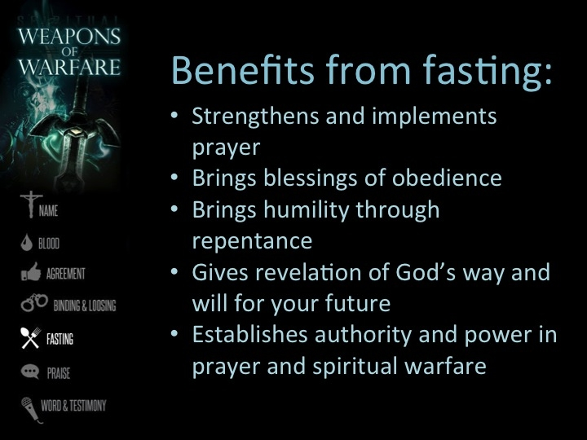

Church Daniel Fast / Healthy Eating Guide
A Spiritual & Health Reset Plan
This fast focuses on clean, natural foods that nourish the body while promoting spiritual discipline and prayer. Participants should eat simple whole foods and avoid processed foods, added sugars, fried foods, and stimulants.

Foods You CAN Eat

Fruits
- Apples | - Strawberries | - Watermelon | - Grapefruit
- Bananas | - Blueberries | - Peaches | - Lemons
- Oranges | - Pineapple | - Pears | - Figs
- Grapes | - Mango | - Kiwi | - Limes

Vegetables
- Broccoli | - Carrots | - Tomatoes | - Mushrooms
- Spinach | - Cabbage | - Bell peppers | - Onions
- Kale | - Zucchini | - Green beans | - Garlic
- Collard greens | - Cucumbers | - Sweet potatoes | - Asparagus

Nuts (Eat in Moderation)
- Almonds | - Pecans | - Pistachios
- Walnuts | - Cashews | - Brazil nuts

Natural Drinks
- Water (best choice) | - Lemon water | - Cucumber water | - Natural fruit juice (100% juice, no added sugar) | - Fresh vegetable juice

Foods You MUST Avoid

Rice, Grains, and Bread
- White rice | - Noodles
- Brown rice | - Tortillas
- Bread | - Oatmeal
- Rolls | - Cereals
- Pasta | - Crackers

ALL MEATS
- Bacon | - Pork chops | - Hot dogs | - Ground beef
- Ham | - Seafood | - Steak | - Chicken

Sweets and Desserts
- Candy | - Cakes | - Ice cream | - Brownies
- Chocolate | - Cookies | - Doughnuts | - Sweet pastries

Fried Foods
- French fries | - Fried chicken | - Fried fish | - Onion rings | - Fried shrimp | - Fried vegetables

Dairy Products
- Milk | - Cheese | - Yogurt | - Ice cream | - Cream | - Butter | - Sour cream

Soda, Caffeine, and Sports Drinks
- Soda | - Soft drinks | - Coffee | - Energy drinks | - Powerade | - Gatorade | - Sweet tea

Sugar and Sugar Additives
- Table sugar | - Honey | - Syrups | - Artificial sweeteners | - Sweetened sauces

Fast Food
- McDonald's | - Burger King | - Wendy's | - Chick‑fil‑A | - Taco Bell | - Pizza chains

Example Daily Meal Plan
Breakfast
- Apple slices, water with lemon
Lunch
- Large vegetable salad and almonds
Snack
- Mixed berries with walnuts
Dinner
- Steamed broccoli and carrots and fresh fruit

Helpful Tips
- Read labels to avoid hidden sugars
- Prepare meals at home when possible
- Eat simple, natural foods
- Drink at least 6–8 glasses of water daily
- Focus on discipline, health, and spiritual growth during the fast



HAVE FOCUSED PRAYER SO YOU CAN RECOGNIZE GOD’S RESPONSE

For our 6-day of Fasting and praying, we have put together a devotional prayer guide to help us to focus during the fast. For each day, there is a suggested topic with corresponding scriptures, and a suggested prayer. We urge you to read and participate in the daily readings so that as a church family we can be on one accord. (Special thanks to Min. Ossie Burton for composing the devotional readings)

Below, you will find additional topics to pray for while you are fasting. Feel free to write down your thoughts as God reveal them to you as you fast and pray.

SOME THINGS YOU CAN PRAY ABOUT:

Your calling
He has saved us and called us to a holy life; not because of anything we have done but because of his own purpose and grace. This grace was given us in Christ Jesus before the beginning of time. 2 Timothy 1:9

Direction
Trust in the Lord with all thine heart and lean not unto thine own understanding. In all thy ways acknowledge him and he shall direct thy paths. Proverbs 3:5-6

Wisdom
“For the Lord gives wisdom; from His mouth comes knowledge and understanding.”
Proverbs 2:6

Opportunities for Gospel Ministry
Pray that God will give us an opportunity to tell people his message. Colossians 4: 3

Favor
For You, O Lord, will bless the righteous with favor…You will surround him as with a shield. Psalms 5:12

Boldness
Also pray for me—that when I speak, God will give me words so that I can tell the secret truth about the Good News without fear Ephesians 6:19

The Church
There should be no division in the body, but that its parts should have equal concern for each other. If one part suffers, every part suffers with it; if one part is honored, every part rejoices with it. Now you are the body of Christ, and each one of you is a part of it. 1 Corinthians 12: 25-27

Church Leaders
Have confidence in your leaders and submit to their authority, because they keep watch over you as those who must give an account. Do this so that their work will be a joy, not a burden, for that would be of no benefit to you. Hebrews 13:17

Government Leaders
I urge, then, first of all, that petitions, prayers, intercession and thanksgiving be made for all people; for kings and all those in authority, that we may live peaceful and quiet lives in all godliness and holiness. 1 Timothy 2:1-2


DAY 1- MONDAY, MARCH 30, 2026

LORD, PREPARE MY HEART

MORNING- Psalm 51:7 – Cleanse me with hyssop, and I will be clean; wash me and I will be whiter than snow.

EVENING - Psalm 51:10- Create in me a pure heart, O God, and renew a right spirit within me,

As we begin our fasting devotional journey, under the theme "Walking In the Authority of God," let us ask the Lord to prepare our hearts as a sacred place, set apart for God's presence to enter in. As we seek to become vessels where God's Spirit may dwell, allow him to shape our thoughts, words, and actions. Perhaps we have gotten off track or allowed “unwanted” visitors, to come into our spirit. The hyssop plant is used as a divine metaphor for purification and cleansing the inside of our hearts and minds.

Supplication: Invite God to cleanse us today—to remove anything that stands between us and his perfect will. Let us Surrender our hearts, our minds and our bodies. Invite Him in our lives to purify and renew us.

Prayer Guide:
Lord, I ask you to wash me inside out. Please forgive my actions that displease you.
Help me to walk in Your authority and reflect Your love in all I do. Amen."


NOTES:
____________________________________________________________________________________________________________________________________________________________________________________________________________________________________________________________________________________________________________________________________________________________________________________________
____________________________________________________________________________

DAY 2 –TUESDAY, MARCH 31, 2026
GUIDE ME
Note: To "walk in authority," you must know which direction to go.

MORNING: Psalm 37:23 The LORD directs the steps of the godly, He delights in every detail of their lives.

EVENING: Isaiah 30:21 And whether you turn to the right or to the left, your ears will hear this command behind you: This is the way. Walk in it.

To walk in authority, one must know which direction to go. Many times, we fail to exercise our God-given power simply because we are unsure of our next step. Uncertainty can make even the strongest believer hesitate. It’s like traveling to an unfamiliar place without directions or a GPS. You move slowly, second-guess your turns, and sometimes end up going the wrong way. But once you enter the address into your GPS, everything changes. You drive with confidence, freedom, and purpose—because now you know where you’re going. In the same way, we must seek God for direction in every area of lives. When He reveals the path, our responsibility is to follow. The Holy Spirit is faithful to guide us, to speak to us, and to steady us.

Supplication: Some roads will be long. Some seasons may feel dark or uneven. But even then, we must carry the authority to speak to every obstacle and keep moving forward. Stay focused. Stay submitted. Stay confident in the One who directs our steps.

Prayer Guide:
Lord, help me to seek your face in all things. Show me the way to Go. Please Help me to not doubt you and your leading, but to follow your leading in my life. When the road is tough, help me to stay focused and committed to your words. In Jesus name, Amen.

NOTES:
___________________________________________________________________________________________________________________________________________________________________________________________________________________________________________________________________________________________________________________________________________________________________________________________



DAY 3- WEDNESDAY
APRIL 1, 2026

YOU ARE MADE NEW

MORNING – 2 Corinthians 5:17 Therefore, if anyone is in Christ, he is a new creation. The old has passed away; behold, the new has come.

EVENING-Isaiah 43:18-19 Remember not the former things, neither consider the things of old. Behold, I am doing a new thing; now it springs forth, do you not perceive it?
Although we may feel unchanged and still experience similar challenges, faith assures us that we have become new! The struggles we are experiencing aren’t there to destroy us, but to strengthen us.

The Butterfly Reminder. Think of a caterpillar becoming a butterfly. Before its transformation is visible, it must wrestle its way out of the cocoon. To someone watching, the struggle might look hopeless — but without that struggle, its wings would never develop, and it would never be able to fly. A few more pushes… A few more twists… And the transformed caterpillar emerges as a beautiful butterfly.

Supplication: Your Situation vs. Your Identity
Your situation may look the same, but you are not.
You are new.
You are changing.
You are becoming stronger.
And you will fly.

No one may have told you this today, so let me: You are new — and you look different.

Prayer Guide:
Lord, guide us to grow into who you intend us to be. Guide me through life's challenges so I can reach my goals. In Jesus name, Amen.

NOTES:
____________________________________________________________________________________________________________________________________________________________________________________________________________________________________________________________________________________________________________________________________________________________________________________________

DAY 4 – Thursday,
APRIL 2, 2026

A DIFFERENT VIEW

MORNING- Psalm 119:37 AMP - Turn my eyes away from vanity [all those worldly, meaningless things that distract—let Your priorities be mine], And restore me [with renewed energy in Your ways.

EVENING- 2 Corinthians 4:18(a) – So we fix our eyes not on what is seen, but on what is unseen.

Distractions are everywhere. The world would have us focus on everything from our house to the white house. We have family issues, all types of trouble, but God has given us the ability to make it. But we must stay focused. We must look at things as God would have us to. God is all powerful. There is nothing that he can’t do.

Supplication: I shift my eye to you, no longer glorifying the problem but glorifying the Problem Solver, (God).

Prayer Guide: Lord, please keep me from focusing on the things of the world, the worldly desires, the worrying, anything that takes my eyes and mind from you. Help me to see everything through your lens. In Jesus name, Amen.

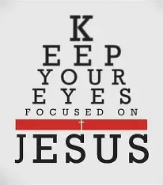

NOTES:
________________________________________________________________________________________________________________________________________________________________________________________________________________________________________________________________________________________________________________________________________________________________________________________________________________________________________________________________________________________________________________________________________________________________________________________________________________________________

DAY 5- FRIDAY, APRIL 3, 2026 

CHANGE OUT OF THE OLD
AND PUT ON THE NEW

MORNING – Ephesians 4:22–24
“To put off your old self, which belongs to your former manner of life and is corrupt through deceitful desires, and to be renewed in the spirit of your minds, and to put on the new self, created after the likeness of God in true righteousness and holiness.”

EVENING – Hebrews 12:1–2
“Therefore, since we are surrounded by such a huge crowd of witnesses to the life of faith, let us strip off every weight that slows us down, especially the sin that so easily trips us up. And let us run with endurance the race God has set before us.”

Every day, we change our clothing. To do so, we must remove what we previously wore and replace it with something fresh. Unless someone requires assistance, this change is intentional and self-initiated. The same principle applies to spiritual transformation.

God has given you salvation and the grace to become new—but you still had a role to play. You had to accept His free gift and invite Him into your life. In the same way, God has given you the power and authority to be completely transformed, yet you must actively participate in that process.

To walk in deliverance, you must put off the old patterns, habits, and mindsets, and put on the new identity God has provided. Even in this, you are not alone. The Holy Spirit stands ready to assist you in every step of your daily spiritual “dressing,” empowering you to make the changes that align with God’s will. You have been fully equipped.

Supplication
To put off the old and put on the new, you must first have the mindset to do so. Transformation requires intentional action. You must participate in the process.

Prayer
Dear Lord, I am weary of walking in the habits of the old me. Please help me to put off the old ways and put on the new. Give me the desire to make the changes I need and then strengthen me to do what is required. In Jesus’ name, Amen.

NOTES:
________________________________________________________________________________________________________________________________________________________________________________________________________________________________________________________________________________________________________________


DAY 6 –SATURDAY, APRIL 4, 2026

WORSHIP THE GREAT GOD:
THE JOY OF THE LORD IS YOUR STENGTH

Morning — Nehemiah 8:5–6 Ezra stood on the platform in full view of all the people. When they saw him open the book, they all rose to their feet. Then Ezra praised the Lord, the great God, and all the people chanted, “Amen! Amen!” as they lifted their hands. Then they bowed down and worshiped the Lord with their faces to the ground.

Evening — Nehemiah 8:10 And Nehemiah continued, “Go and celebrate with a feast of rich foods and sweet drinks, and share gifts of food with people who have nothing prepared. This is a sacred day before our Lord. Don’t be dejected and sad, for the joy of the Lord is your strength!”

Devotional
Open the Word and read the Word. Hear the Word. Lift up your hands and your heart, and praise our mighty God—no matter what. As we empty ourselves before Him and acknowledge that He is our strength, renewal begins to flow. Praise Him! You have been strengthened. You have been equipped. Now go out in that strength and encourage someone else. The more we praise Him, the more we accept His will for our lives. As we surrender, His joy fills us. Put off sadness and leave it on the altar. Receive and walk in the joy of the Lord. The joy of the Lord is your strength.

Supplication
When sadness, depression, anger, or doubt tries to raise its ugly head, praise Him in your heart. Lift up your hands. Rejoice in the Lord—and rejoice again.

Prayer
Lord, I thank You and I praise You. You are the Great God. Fill me with Your joy, as only You can. When negative emotions try to rise up, help me to stop worshiping the issue and instead worship the Problem Solver. Teach me to live in a continual state of praise and worship, for that is where my strength comes from. Amen.

NOTES:
________________________________________________________________________________________________________________________________________________________________________________________________________________________________________________________________________________________________________________
SUNDAY, APRIL 5, 2026 (EASTER SUNDAY MORNING)

WE DID IT….

Today, let’s worship together for our Sunrise Service and fellowship together with our Annual Easter Breakfast. Remember, Jesus died for our sins and has risen from the tomb. He is Alive. And with all the scriptural readings, the prayers lifted this week, let us too rise and walk in AUTHORITY just as Christ did.

Now that we have completed our Holy Week Fast and Prayer, what do we do now? Simple, continue to get closer to our God. Continue seeking ways to stay committed to reading His Word on a daily basis, crave out time in our schedule to pray and communicate to Him, become even more active in your church, look for ways to serve others, and always have an evangelistic mindset by witnessing to others about Christ’s love for them. Let us live every day to please our God and ready to share His love.

Remember, we were created for His glory; to do good and godly work and to live out our purpose here on earth. We must stay focus on our calling and do all we can to fulfill our purpose. Though the world will present distractions to us, to keep us from our purpose, it is up to us to remain steadfast and be determined in doing all we were created to do. And so I conclude our guide with the words from the apostle Paul when he wrote to the church of Colossae in that 3rd chapter. Paul said, “Since you were brought back to life with Christ, focus on the things that are above—where Christ holds the highest position. Keep your mind on things above, not on worldly things. You have died, and your life is hidden with Christ in God. Christ is your life. When he appears, then you, too, will appear with him in glory.” Let us live for Him and do the things He called us to do.



All for His Glory,

George P. Windley, Jr.

George P. Windley, Jr., Pastor

